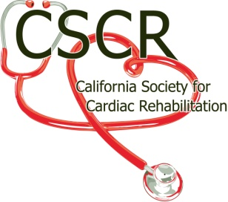

CSCR BOARD OF DIRECTORS
Title: Member at Large
Primary Purpose: Provide an opportunity a Past CSCR President to share his/her expertise and experience to the CSCR Board of Directors
Appointment: Appointed by CSCR's State President with the approval of CSCR's Board of Directors by majority vote
Reports To: The President of CSCR
Serves: Serves a 1 year term, changing at the discretion of the current President
Requirements: Prior member of the Executive Board
Current CSCR member
Attend all Board of Director Meetings or Conference phone calls
Attend Annual Educational Conference
Principle Duties:
- Board of Directors responsibilities
  - Reports
    - Presents a written report reflecting position activity to date at each Board Meeting and the Annual State Membership meeting.
    - When requested, presents a report of position activities to the Communication Director Website publication
  - Other Board responsibilities
    - Is available for the Speaker’s Bureau
    - Perform other duties as requested by the CSCR President and Board
- Position Responsibilities
  - Provides suggestions to the Executive Board based on historical or personal experience concerning the operations of the Organization
  - Assists with the mentoring of incoming Board members both after the Annual meeting and during the year
  - Coordinates the Past Presidents’ lunch or reception at the Annual meeting, when possible
  - Encourages previous CSCR Presidents to continue their CSCR activities
  - Assists with the acquisition of awards and plaques for annual awards
  - Initiates state grass roots writing campaigns when directed by AACVPR and CSCR
  - Personally maintains awareness of current National Legislative and Reimbursement activities

