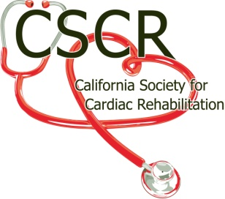

Title: Regional Representative

Primary Purpose: To chair all regional educational conferences and programs, networking
meeting and other regional meetings.

Reports To: The President and Board of Directors of CSCR.

Serves: A one year term.
Appointed by the CSCR President and Board of Directors.

Requirements: Current member of CSCR
Attend all Board of Director’s Meetings or Conference Calls.
Attend Annual Educational Conference and Membership Meeting.

Principle Duties:

I. Board of Directors responsibilities.

A. Reports

1. Presents a written report reflecting position activity to date at all Board

meetings.

2. Presents a written summary of position activities at Annual State

Membership meeting.

3. Contributes position activity report for publication on Website as requested.

B. Other Board responsibilities

1. Be available for Speakers Bureau.

2. Performs other duties as directed by the CSCR Board of Directors.

II. Regional Educational Conference / Networking Meetings

A. Organize and present at least one Educational meeting a year

1. See attached list for the responsibilities associated with that activity.

B. Organize at least 1 Networking meeting per year.

1. Networking meeting may be associated with Educational meeting or at a

separate time.

III. Regional promotion of CSCR / Awards

A. Serves as the regional spokesperson for CSCR.

B. Promotes participation and membership in CSCR.
- Promote and coordinate the nomination and the awarding of the annual Award of Excellence for a member in his / her region.

